## 



**GRADUATE DIPLOMA IN SOFTWARE ENGINEERING**

Online Supplement & Nutrition Store

28.12.2018

**─**

**Jamith Nimantha**

GDSE 46

981102134V

**LECTURER: Mr. Sanu Vithange**

**Table of Contents**

1. **Abstract**
2. **Overview**
3. **Problem Statement**
4. **Requirement Analysis Process**
5. **Functional Requirements**
6. **Non-Functional Requirements**
7. **Software and Hardware Requirements**
8. **Technologies Using**
9. **Use Case Diagram**
10. **Entity Relationship Diagram**

# Abstract

This task was carried out to develop a online system for a supplement & nutrition shop. The objective of the **“Supplement & Nutrition Store”** is to provide a system which handles the information of the customers coming into the store and buying products. It take care of all their nutrition needs. Data will be stores in the databases. It also maintains Order records and payment records. Than a manual system in this system can handle all the process easily.

# Overview

The objective of the **“Online Supplement & Nutrition Store”** is to provide a Online solution for the manual system. So the anyone in the country can order a product online by the website without coming to the store.

# Problem Statement

The following are some problems of the **Supplement & Nutrition Store** that are present on conventional approaches.

* Maintaining the customer details, order details, product details and payment details are difficult.
* Need more employers for process.
* No back up data.
* Getting reports are difficult.
* Customers are busy to visit the store.

In the present days store staff note down the details like customer details, manufacturer details, payment details as hard documents. So this is very primary method today. It is a wasting time of money and time. If the hard document misplaced they have to face a big trouble.

# Requirement Analysis Process

First basic process of the **“Supplement & Nutrition Store”** were identifies. Then those processes were analyzed one by one in order to identify the users and their basic functions and their requirements .Then the process which can be automated were separated from others. Then deep analyzing is placed to those processes which can be automated by considering that the users do? How they Do?

# Functional Requirements

The main functional requirements can be classified as follows.

* Customer Management
  + Customers can be able to register, update or delete.
  + Search Customers
  + Give Discounts to Customers.
* Product Management
  + Products can be add, update or delete.
  + Get product reports.
  + Search Products.
* Payment Management
  + Collectors notes every records about monthly payments and register payment.
  + Can be able to create automatically.
  + Make payment easily.
  + Can be able to get payment Reports

# Non-Functional Requirements

* User Friendliness
  + Customers and users able to to easily use the system to place order and maintaining the system and get reports.
* Backup
  + System administrators should be able to backup databases.

# Software and Hardware Requirements

* CPU: 3.00 GHZ single core processor/2.00 GHZ dual core processor
* Hosting Services for Server Hosting with Minimus 512MB of Disk and 25 of RAM
* Recommended 2GB of RAM.
* Browsers: Google Chrome, Mozilla FireFox
* Network Card
* Internet Connection
* Operating System : Windows 10, Ubuntu 16.04

# Technologies Using

Technologies using to implement the system.

* Markup Languages (Front End)
  + HTMl
  + CSS
* Programming Languages
  + JavaScript
  + PHP
* IDE
  + Jetbrains PHPStorm
  + Sublime Text
* Server
  + Apache2
  + Mysql 5.7
  + Phpmyadmin

# Use Case Diagram

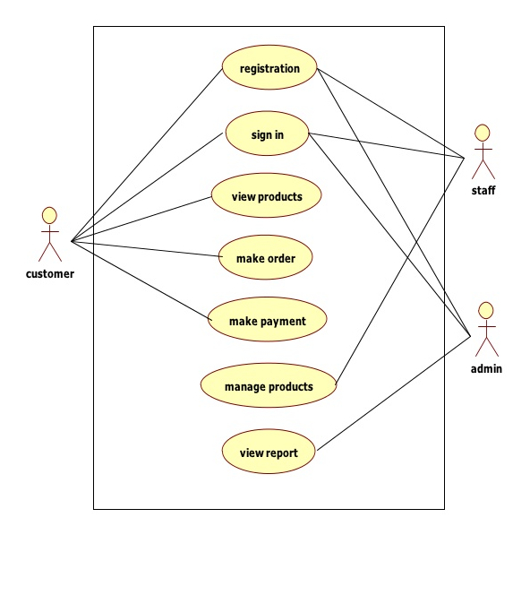

# Entity Relationship Diagram

